Project Design Phase-II
Data Flow Diagram & User Stories

Date | 31 January 2025
Team ID
Project Name
Maximum Marks | 4 Marks

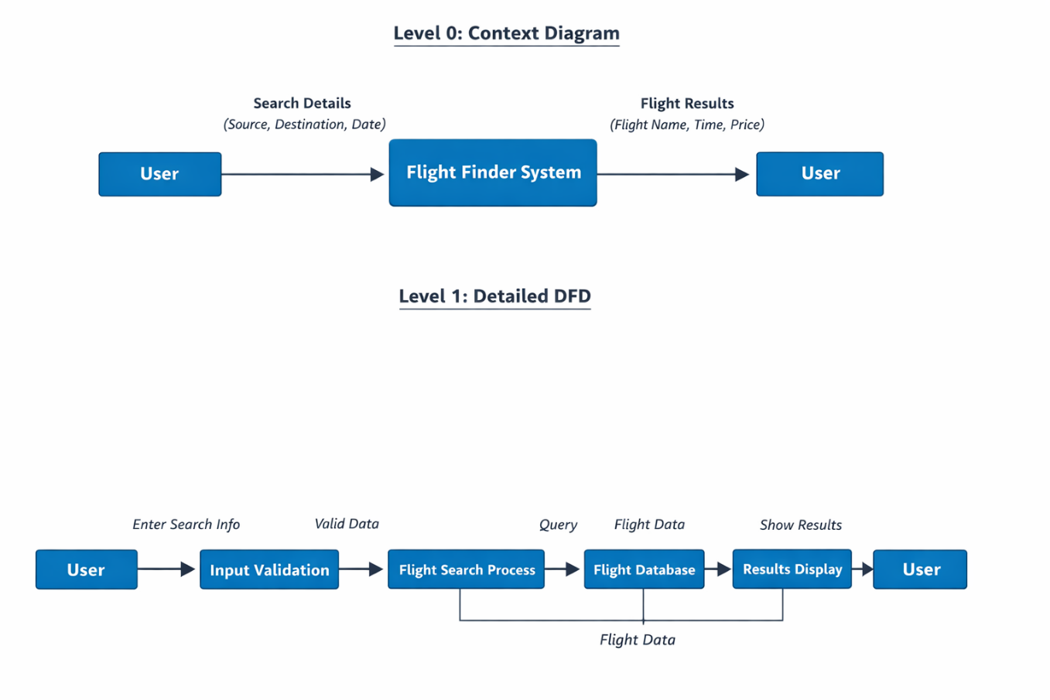s

User Stories
User Type | Functional Requirement (Epic) | User Story Number | User Story / Task | Acceptance Criteria | Priority | Release
Customer (Web User) | Flight Search | USN-1 | As a user, I can search flights by entering source and destination. | Flights should be displayed based on input. | High | Sprint-1
Customer (Web User) | Flight Search | USN-2 | As a user, I can select travel date. | System should accept date and show flights. | High | Sprint-1
Customer (Web User) | Flight Results | USN-3 | As a user, I can view flight details. | Flight name, time and price should be displayed. | High | Sprint-1
Customer (Web User) | Interface | USN-4 | As a user, I can use a simple interface to search flights. | Interface should be easy to use. | Medium | Sprint-1
Customer (Web User) | Validation | USN-5 | As a user, I should receive error messages for empty inputs. | Error message should be displayed. | Medium | Sprint-1

Administrator
User Type | Functional Requirement (Epic) | User Story Number | User Story / Task | Acceptance Criteria | Priority | Release
Administrator | Flight Data Management | USN-6 | As an admin, I can add flight details. | Flights should be stored correctly. | High | Sprint-2
Administrator | Flight Data Management | USN-7 | As an admin, I can update flight details. | Updated data should be visible. | Medium | Sprint-2
Administrator | Flight Data Management | USN-8 | As an admin, I can delete flight details. | Flights should be removed successfully. | Medium | Sprint-2

